The First World Lab Animal Day (WLAD) in China
V1.5 Aug 2008
The Report of the first WLAD by Chinese Animal Protection Network (CAPN)
For the first time, World Lab Animal Day is commemorated by people in China this April and May. Chinese Animal Protection Network, introduced this event into China, we are delighted to present the detail of the event and wish to share the experience with all people concerning the animal rights movement in China.

Background
Although lab animals’ protection has been a very active chapter of the animal rights history in the west, the whole Chinese advocacy community had very limited awareness or action on the issue. Before this March, if searching "世界实验动物日"（Chinese translation of WLAD）in several most popular search engines, one can find almost nothing relevant.[3]. as a group pioneered many area of animal protection in the past several years [2], we are long aware the gap of lab animal protection in the country. Thus we decided to introduce WLAD into China this year.

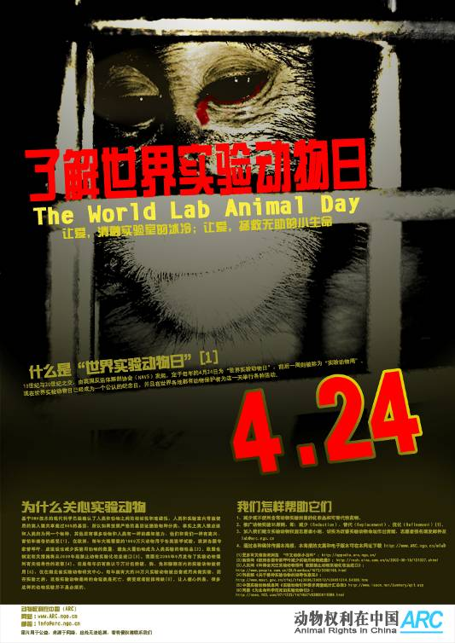
Method
Our preparation for the WLAD (24th April) starts long before 24th of April. First we surveyed the lab animal usage in China then put the result into an open letter. In the letter we 1) demonstrate the urgency, significance of the lab animal protection; 2) introduce the history of WLAD and 3) call people around the country join us to commemorate the first WLAD this April. Despite of the open letter, we also prepared other educational material such as posters, banners and articles. All those materials are published via one of our website project 'Animal Rights in China' (http://www.arc.ngo.cn) and our cooperative network.

Result
This open letter was a big success; it is circulated over Internet by our supporters and has brought lots of rational online discussion [1]. Its worth to mention, many supporters are actually from research/educational institutions which use lab animals.
Lab Animal Management Committee of Jiangsu Province (a governmental department) republished one of our WLAD article on their website and put the link of that article on the homepage.
http://www.jsdw.org/dw/
Hefei Evening, a regional newspaper with about 260,000 circulations, introduced WLAD in one of its articles on 23 of April.
We also received many echoes offline - supporters around country organized inspiring local events since 24th April to May.
Below are some of the offline events/actions
- 24th of April, the head of Medical College of Nanjing Agriculture University organized an offline petition on the campus to commemorate WLAD.
Report of this event on the universities website:
http://grasch.njau.edu.cn/ygb/showarticle.asp?id=694
- 24th of April, an university student organized an offline petition on his campus with the help of other members of his organization. Photo on the right is from this event. The student’s original report can be found: http://www.povchina.ngo.cn/bbs/viewthread.php?tid=8191
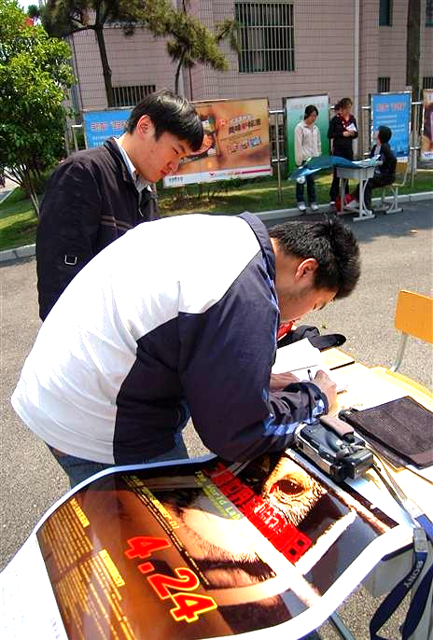
- The Volunteer organization of Life Science College of South China Agriculture University organized series events to commemorate WLAD this May. The events are: 1) a survey of students’ attitude towards lab animal, 2) organizing students to visit local animal shelter 3) and a lecture on animal protection to students.
- 22nd of April, Chengdu animal group 'Home of Love' displayed the poster and commemorate WLAD on their event.
- Environmental group 'green camel bell' organized educational activities of WLAD in their office and local zoo
Many other supporters around countries requested the educational poster from us and displayed it locally. In total 1000 posters have been sent to following destination for display
  - Guangzhou, Yangzhou, Lanzhou, Shanghai, Tianjing, Dongguan, Chengdu,
  - Beijing University, University of Science and Technology Beijing, Northeast Normal University (Changchun), Nanjing Forestry University, Northwest Normal University (Gansu), Zhangzhou Normal University, West China Normal University (JinZhong)
We thank Compassion for Animals Foundation for the funding of printing of posters; we thank everyone who has helped us to spread the message of WLAD in China. The journey of lab animal protection has just begun!

Endnote
[1] Chinese result of WLAD in Google and Baidu (a popular Chinese search engine)
Google result: http://www.google.com/search?hl=en&rls=com.microsoft%3Aen-US&q=+%E4%B8%96%E7%95%8C%E5%AE%9E%E9%AA%8C%E5%8A%A8%E7%89%A9%E6%97%A5
Baidu result: http://www.baidu.com/s?wd=%CA%C0%BD%E7%CA%B5%D1%E9%B6%AF%CE%EF%C8%D5
Almost all pages appear after this year’s event.
[2]Since the founding of our group, we have leaded several important trends in the Chinese advocacy community, such as: 1) changing of pro-hoarding climate, 2) unity and networking of advocacy groups. 3) Recognition of stop eating cat-dog-meat campaign. For more information about CAPN please visit our website: http://www.capn.ngo.cn or write to us info@capn.ngo.cn
[3] Our search of '世界实验动物日' (world lab animal day) by Google this March only return one article contain this keywords, it’s a page on the library section of one of our website.

